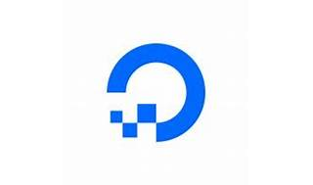



Explore

[**DigitalOcean** is an American multinational technology company and cloud service provider that offers cloud infrastructure-as-a-service platforms for developers, startups, and SMBs](https://en.wikipedia.org/wiki/DigitalOcean) [1](https://en.wikipedia.org/wiki/DigitalOcean). It simplifies launching and scaling cloud resources, whether you’re running one virtual machine or ten thousand.

Here are **five free learning resources** to explore DigitalOcean:

1. [**DigitalOcean Community Tutorials**](https://www.digitalocean.com/community/tutorials): Follow along with over **7,000 development and sysadmin tutorials** covering various topics, including cloud infrastructure, programming, and system administration [2](https://www.digitalocean.com/community/tutorials).
2. [**Introduction to the Cloud**](https://www.digitalocean.com/blog/learning-on-the-cloud-expanding-digitaloceans-partnership): A self-guided course for beginners, perfect for understanding cloud concepts [3](https://www.digitalocean.com/blog/learning-on-the-cloud-expanding-digitaloceans-partnership).
3. [**High Availability Setup with Heartbeat and Floating IP**](https://www.douglashollis.com/best-digitalocean-course-training-class-tutorial-certification-online/) (Udemy Course): Learn how to configure a simple high-availability cluster using DigitalOcean VPS [4](https://www.douglashollis.com/best-digitalocean-course-training-class-tutorial-certification-online/).
4. [**DigitalOcean Cloud Platform Fundamentals**](https://www.udemy.com/course/digitalocean/) (Udemy Course): Explore cloud services, Droplets, Spaces API, load balancers, and more [5](https://www.udemy.com/course/digitalocean/).
5. [**Learning Paths**](https://www.digitalocean.com/community/learning-paths): Choose from common learning paths and goals, including JavaScript, React, Python, Go, SQL, and PHP [6](https://www.digitalocean.com/community/learning-paths).

Happy learning! 🚀